MULTISITE GRANT MANAGEMENT SYSTEM

Expense Entry

User Guide Document

Ver. 1.4

Version History
Date | Description
25-Oct-2010 | First Draft

Table of Contents

Version History 2
1 Introduction 4
1.1 Purpose 4
1.2 View expenses for a period 5
1.3 View expenses head wise 6

Introduction

Purpose

This document provides the step-by-step instructions for recording expenses incurred for the projects undertaken in the institution, in the Multisite Grant Management System.

Please note that this is a ‘living document’ and the specification will change, continuously, as the project proceeds. More details will be added and the existing information edited as the requirements, scenarios and use cases evolve in the course of the project.

Click on Record Expenses from the Project Dash Board to enter the Daily Expenses under various Heads.

Figure 1: Project Home - Record Expenses tab
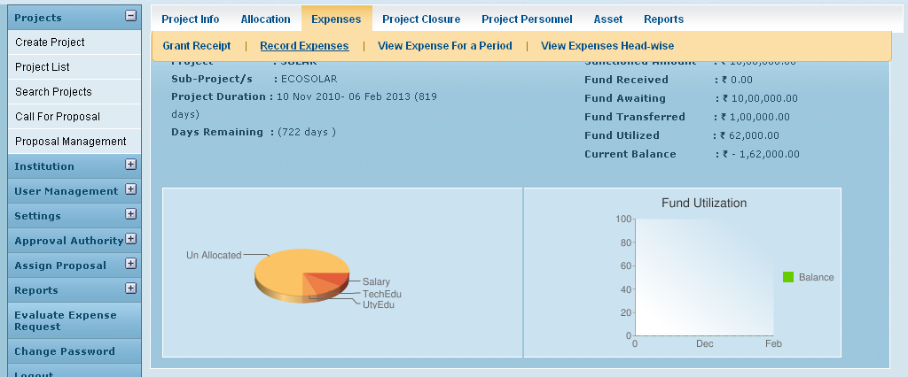
Click on Record Expense to enter the Head wise Daily Expenses

Expenses are recorded against a specific grant allocation. It is not necessary that the funds required be already available i.e. over utilization is possible. And can be paid for once the fund is transferred. But please note that the entered expense amount should not cause total expenses to go beyond the allocated amount.

After entering the Details, Click on Create Link to Save the Entry. Account Head Wise Expense Summary will be displayed below the Expense Entry Page.

Figure 2: Expense entry page
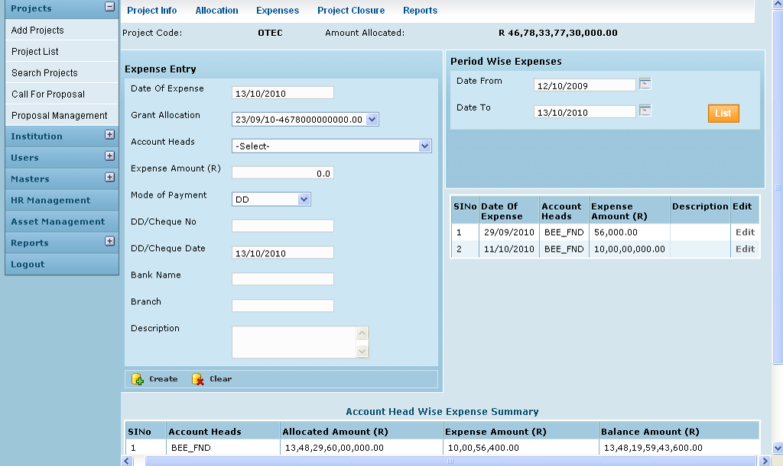
Click on Create Link to Record the Expenses.

View expenses for a period

By clicking View expenses for a period tab (Fig 1) the following page is opened where for a user specified date range, the expense amounts and associated account heads are displayed.

Figure 3: View expenses for a period
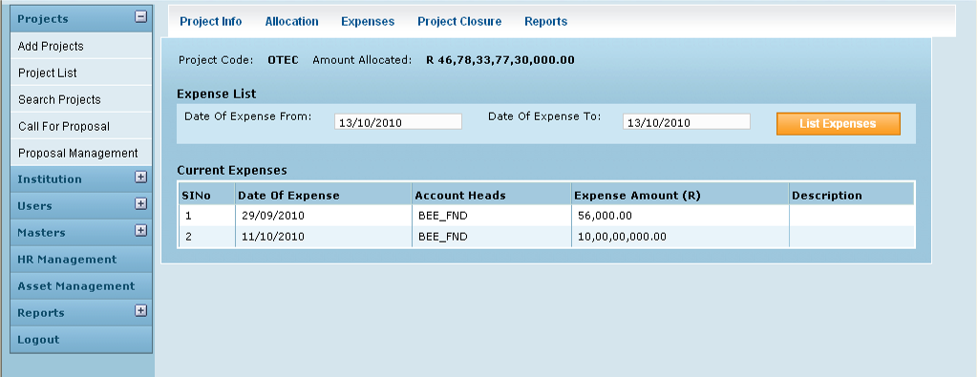

View expenses head wise

Here the user can view total expenses till date since the project started for a specific or all account heads.

Figure 4: Summary of Expenses
